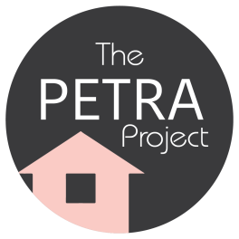 Application Form

The Petra Project provides housing, support and life skills for up to two years, to help mothers and mothers-to-be to prepare and move on to independent living.

- All potential client applications will be looked at by The Petra Project manager.
- Potential clients will be invited to an interview to check that they fit the criteria and that options such as mediation have been looked into.
- If The Petra Project has no available places potential clients will be kept on a waiting list and updated monthly.

Criteria -
Mother age 16-25
Pregnant (12 weeks+) or has a child
Homeless or facing homelessness
Currently live in the B&NES area

Referral Agency/Name of person making referral
Job Title
Email Tel
Potential client’s information
Name Tel
Date of Birth / /
Pregnant Y / N
Due date / /
Child(s) Name
Date of Birth / /
Current address
Housing situation
Leaving Care Y / N
Living with family Y / N
Hostel/other supportive placement Y / N
Sofa surfing Y / N
Friend Y / N
Other
Reason for homelessness:

Work/Education
Are you currently in work or Education? Y / N
Other details
Benefits
Are you currently receiving
Housing Benefit Y / N
Universal Credit Y / N
Child Benefit Y / N
Other
Other information
Any Disability or Health problems? Y / N
Any other information

Any issues with domestic Abuse? Y / N Current Previous
Any other information

Any issues with substance misuse? Y / N Current Previous
Any other information

Any other support needs?

